1995 年 AMC 8 真题与解答
American Mathematics Competitions 8 · 中英双语
共 25 题，限时 40 分钟；单项选择题，每题 1 分，答错不扣分，满分 25 分。
内容来源：LIVE by Po-Shen Loh（live.poshenloh.com）历年 AMC 8 真题与解答，试题经美国数学协会（MAA）官方授权使用；本文档由本地整理生成，供个人学习使用，版权归原作者及 MAA 所有。
编排说明：第一部分为题目（先中文、后英文原题），第二部分为解答与答案，便于先做题后对答案。
第一部分 题目
第 1 题
沃尔特口袋里正好有一枚一美分硬币、一枚五美分硬币、一枚十美分硬币和一枚二十五美分硬币。他口袋里的钱是一美元的百分之几？
（A）4% （B）25% （C）40% （D）41% （E）59%
English
Walter has exactly one penny, one nickel, one dime and one quarter in his pocket. What percent of one dollar is in his pocket?
(A) 4% (B) 25% (C) 40% (D) 41% (E) 59%
第 2 题
何塞比扎克小 4 岁。扎克比伊内兹大 3 岁。伊内兹 15 岁。何塞几岁？
（A）8 （B）11 （C）14 （D）16 （E）22
English
Jose is 4 years younger than Zack. Zack is 3 years older than Inez. Inez is 15 years old. How old is Jose?
(A) 8 (B) 11 (C) 14 (D) 16 (E) 22
第 3 题
下列哪种运算对一个数的作用，与先乘以 3/4 再除以 3/5 相同？
（A）除以 4/3 （B）除以 9/20 （C）乘以 9/20 （D）除以 5/4 （E）乘以 5/4
English
Which of the following operations has the same effect on a number as multiplying by 3/4 and then dividing by 3/5?
(A) dividing by 4/3 (B) dividing by 9/20 (C) multiplying by 9/20 (D) dividing by 5/4 (E) multiplying by 5/4
第 4 题
老师告诉全班：“想一个数，给它加 1，再把结果加倍。把答案给你的搭档。搭档从得到的数中减去 1，再把结果加倍，得到自己的答案。”本想的是 6，并把他的答案给苏。苏的答案应是多少？
（A）18 （B）24 （C）26 （D）27 （E）30
English
A teacher tells the class, “Think of a number, add 1 to it, and double the result. Give the answer to your partner. Partner, subtract 1 from the number you are given and double the result to get your answer.” Ben thinks of 6, and gives his answer to Sue. What should Sue’s answer be?
(A) 18 (B) 24 (C) 26 (D) 27 (E) 30
第 5 题
求大于下列和的最小整数：
21/2 + 31/3 + 41/4 + 51/5。
（A）14 （B）15 （C）16 （D）17 （E）18
English
Find the smallest whole number that is larger than the sum
21/2 + 31/3 + 41/4 + 51/5.
(A) 14 (B) 15 (C) 16 (D) 17 (E) 18
第 6 题
图形 I、II 和 III 都是正方形。I 的周长是 12，II 的周长是 24。III 的周长是
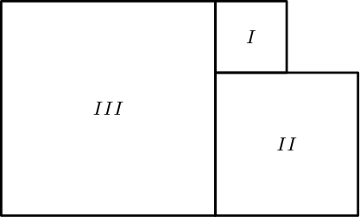
（A）9 （B）18 （C）36 （D）72 （E）81
English
Figures I, II and III are squares. The perimeter of I is 12 and the perimeter of II is 24. The perimeter of III is
(A) 9 (B) 18 (C) 36 (D) 72 (E) 81
第 7 题
在克洛弗维尤初中，一半学生乘校车回家，四分之一乘汽车回家，十分之一骑自行车回家。其余学生步行回家。步行回家的学生占全体的几分之几？
（A）1/16 （B）3/20 （C）1/3 （D）17/20 （E）9/10
English
At Clover View Junior High, one half of the students go home on the school bus. One fourth go home by automobile. One tenth go home on their bicycles. The rest walk home. What fractional part of the students walk home?
(A) 1/16 (B) 3/20 (C) 1/3 (D) 17/20 (E) 9/10
第 8 题
一位在意大利旅行的美国人想把美元兑换成意大利里拉。如果 3000 里拉 = $1.60，那么用 $1.00 可以兑换多少里拉？
（A）180 （B）480 （C）1800 （D）1875 （E）4875
English
An American traveling in Italy wishes to exchange American money (dollars) for Italian money (lire). If 3000 lire = $1.60, how many lire will the traveler receive in exchange for $1.00?
(A) 180 (B) 480 (C) 1800 (D) 1875 (E) 4875
第 9 题
如图，三个全等圆的圆心分别为 P、Q 和 R，并与长方形 ABCD 的边相切。以 Q 为圆心的圆直径为 4，并经过点 P 和 R。长方形的面积是
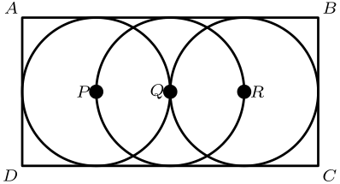
（A）16 （B）24 （C）32 （D）64 （E）128
English
Three congruent circles with centers P, Q and R are tangent to the sides of rectangle ABCD as shown. The circle centered at Q has diameter 4 and passes through points P and R. The area of the rectangle is
(A) 16 (B) 24 (C) 32 (D) 64 (E) 128
第 10 题
一件夹克和一件衬衫原价分别为 $80 和 $40。促销期间，克里斯以 40% 折扣买了 $80 的夹克，又以 55% 折扣买了 $40 的衬衫。节省的总金额是原总价的百分之几？
（A）45% （B）471/2% （C）50% （D）791/6% （E）95%
English
A jacket and a shirt originally sold for $80 and $40, respectively. During a sale Chris bought the $80 jacket at a 40% discount and the $40 shirt at a 55% discount. The total amount saved was what percent of the total of the original prices?
(A) 45% (B) 471/2% (C) 50% (D) 791/6% (E) 95%
第 11 题
简（Jane）走任意距离所用时间是赫克托（Hector）走同样距离所用时间的一半。他们从图中所示 18 个街区区域外侧出发，沿相反方向行走。他们第一次相遇时，最接近哪个点？
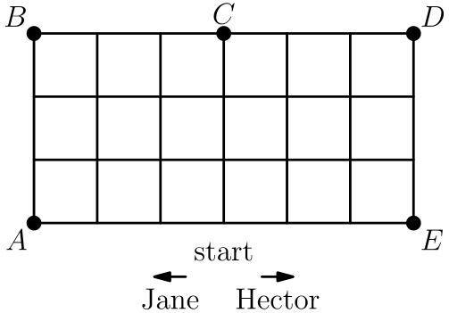
（A）A （B）B （C）C （D）D （E）E
English
Jane can walk any distance in half the time it takes Hector to walk the same distance. They set off in opposite directions around the outside of the 18-block area as shown. When they meet for the first time, they will be closest to
(A) A (B) B (C) C (D) D (E) E
第 12 题
一个“幸运”年份是指至少有一个日期按“月/日/年”的形式书写时，满足月份数乘以日期数等于年份的最后两位。例如，1956 是幸运年份，因为日期 7/8/56 满足 7 × 8 = 56。下列哪一年不是幸运年份？
（A）1990 （B）1991 （C）1992 （D）1993 （E）1994
English
A <i>lucky</i> year is one in which at least one date, when written in the form month/day/year, has the following property: the product of the month times the day equals the last two digits of the year. For example, 1956 is a lucky year because it has the date 7/8/56 and 7 × 8 = 56. Which of the following is NOT a lucky year?
(A) 1990 (B) 1991 (C) 1992 (D) 1993 (E) 1994
第 13 题
图中，∠ A、∠ B 和 ∠ C 都是直角。如果 ∠ AEB = 40°，且 ∠ BED = ∠ BDE，那么 ∠ CDE =
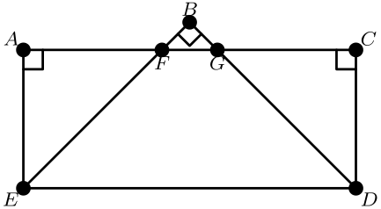
（A）75° （B）80° （C）85° （D）90° （E）95°
English
In the figure, ∠ A, ∠ B and ∠ C are right angles. If ∠ AEB = 40° and ∠ BED = ∠ BDE, then ∠ CDE =
(A) 75° (B) 80° (C) 85° (D) 90° (E) 95°
第 14 题
一支球队在前 50 场比赛中赢了 40 场。为了使整个赛季的胜率正好为 70%，这支球队在剩下的 40 场比赛中必须赢多少场？
（A）20 （B）23 （C）28 （D）30 （E）35
English
A team won 40 of its first 50 games. How many of the remaining 40 games must this team win so it will have won exactly 70% of its games for the season?
(A) 20 (B) 23 (C) 28 (D) 30 (E) 35
第 15 题
4/37 的小数形式中，小数点右边第 100 位数字是什么？
（A）0 （B）1 （C）2 （D）7 （E）8
English
What is the 100th digit to the right of the decimal point in the decimal form of 4/37?
(A) 0 (B) 1 (C) 2 (D) 7 (E) 8
第 16 题
三所中学的学生参加了一个暑期项目。艾伦中学的七名学生工作了 3 天。巴尔博亚中学的四名学生工作了 5 天。卡弗中学的五名学生工作了 9 天。学生工作的总报酬为 $774。假设每名学生每天获得相同报酬，那么巴尔博亚中学的学生总共赚了多少？
（A）$9.00 （B）$48.38 （C）$180.00 （D）$193.50 （E）$258.00
English
Students from three middle schools worked on a summer project. Seven students from Allen School worked for 3 days. Four students from Balboa School worked for 5 days. Five students from Carver School worked for 9 days. The total amount paid for the students’ work was $774. Assuming each student received the same amount for a day’s work, how much did the students from Balboa School earn altogether?
(A) $9.00 (B) $48.38 (C) $180.00 (D) $193.50 (E) $258.00
第 17 题
下表给出安维尔和克利奥纳两所小学各年级学生所占百分比：
<table aria-label="安维尔和克利奥纳各年级学生百分比" style="border-collapse: collapse; margin: 0.6rem auto; text-align: center; font-size: 0.88rem"> <tr> <th style="padding: 0.15rem 0.45rem"></th> <th style="padding: 0.15rem 0.45rem">K</th> <th style="padding: 0.15rem 0.45rem">1</th> <th style="padding: 0.15rem 0.45rem">2</th> <th style="padding: 0.15rem 0.45rem">3</th> <th style="padding: 0.15rem 0.45rem">4</th> <th style="padding: 0.15rem 0.45rem">5</th> <th style="padding: 0.15rem 0.45rem">6</th> </tr> <tr> <th style="padding: 0.15rem 0.45rem">安维尔</th> <td style="padding: 0.15rem 0.45rem">16%</td> <td style="padding: 0.15rem 0.45rem">15%</td> <td style="padding: 0.15rem 0.45rem">15%</td> <td style="padding: 0.15rem 0.45rem">14%</td> <td style="padding: 0.15rem 0.45rem">13%</td> <td style="padding: 0.15rem 0.45rem">16%</td> <td style="padding: 0.15rem 0.45rem">11%</td> </tr> <tr> <th style="padding: 0.15rem 0.45rem">克利奥纳</th> <td style="padding: 0.15rem 0.45rem">12%</td> <td style="padding: 0.15rem 0.45rem">15%</td> <td style="padding: 0.15rem 0.45rem">14%</td> <td style="padding: 0.15rem 0.45rem">13%</td> <td style="padding: 0.15rem 0.45rem">15%</td> <td style="padding: 0.15rem 0.45rem">14%</td> <td style="padding: 0.15rem 0.45rem">17%</td> </tr> </table>
安维尔有 100 名学生，克利奥纳有 200 名学生。两所学校合计，有百分之几的学生在 6 年级？
（A）12% （B）13% （C）14% （D）15% （E）28%
English
The table below gives the percent of students in each grade at Annville and Cleona elementary schools:
<table aria-label="Percent of students in each grade at Annville and Cleona" style="border-collapse: collapse; margin: 0.6rem auto; text-align: center; font-size: 0.88rem"> <tr> <th style="padding: 0.15rem 0.45rem"></th> <th style="padding: 0.15rem 0.45rem">K</th> <th style="padding: 0.15rem 0.45rem">1</th> <th style="padding: 0.15rem 0.45rem">2</th> <th style="padding: 0.15rem 0.45rem">3</th> <th style="padding: 0.15rem 0.45rem">4</th> <th style="padding: 0.15rem 0.45rem">5</th> <th style="padding: 0.15rem 0.45rem">6</th> </tr> <tr> <th style="padding: 0.15rem 0.45rem">Annville</th> <td style="padding: 0.15rem 0.45rem">16%</td> <td style="padding: 0.15rem 0.45rem">15%</td> <td style="padding: 0.15rem 0.45rem">15%</td> <td style="padding: 0.15rem 0.45rem">14%</td> <td style="padding: 0.15rem 0.45rem">13%</td> <td style="padding: 0.15rem 0.45rem">16%</td> <td style="padding: 0.15rem 0.45rem">11%</td> </tr> <tr> <th style="padding: 0.15rem 0.45rem">Cleona</th> <td style="padding: 0.15rem 0.45rem">12%</td> <td style="padding: 0.15rem 0.45rem">15%</td> <td style="padding: 0.15rem 0.45rem">14%</td> <td style="padding: 0.15rem 0.45rem">13%</td> <td style="padding: 0.15rem 0.45rem">15%</td> <td style="padding: 0.15rem 0.45rem">14%</td> <td style="padding: 0.15rem 0.45rem">17%</td> </tr> </table>
Annville has 100 students and Cleona has 200 students. In the two schools combined, what percent of the students are in grade 6?
(A) 12% (B) 13% (C) 14% (D) 15% (E) 28%
第 18 题
在这个 100 英寸乘 100 英寸的正方形中，四个全等 L 形区域中每一个的面积都是总面积的 3/16。中心正方形的边长是多少英寸？
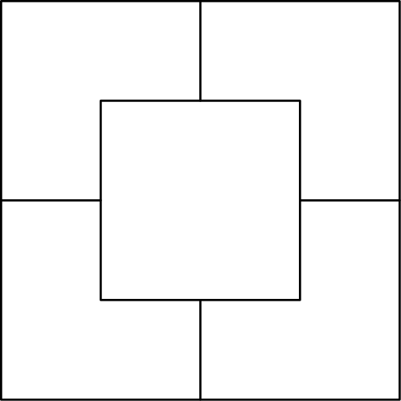
（A）25 （B）44 （C）50 （D）62 （E）75
English
The area of each of the four congruent L-shaped regions of this 100-inch by 100-inch square is 3/16 of the total area. How many inches long is the side of the center square?
(A) 25 (B) 44 (C) 50 (D) 62 (E) 75
第 19 题
图中显示乔丹老师英语班学生家庭中孩子人数的分布。这个分布中，每个家庭孩子人数的中位数是
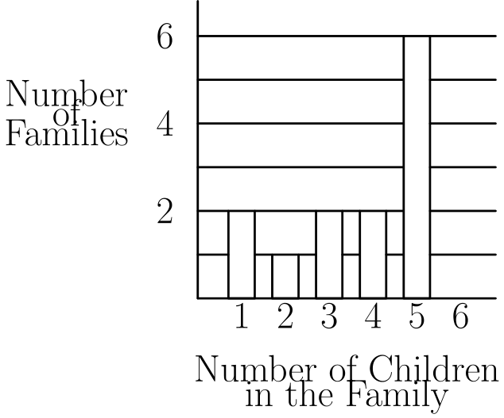
（A）1 （B）2 （C）3 （D）4 （E）5
English
The graph shows the distribution of the number of children in the families of the students in Ms. Jordan’s English class. The median number of children in the family for this distribution is
(A) 1 (B) 2 (C) 3 (D) 4 (E) 5
第 20 题
戴安娜和阿波罗各掷一颗标准骰子，随机得到 1 到 6 中的一个数。戴安娜的数大于阿波罗的数的概率是多少？
（A）1/3 （B）5/12 （C）4/9 （D）17/36 （E）1/2
English
Diana and Apollo each roll a standard die obtaining a number at random from 1 to 6. What is the probability that Diana’s number is larger than Apollo’s number?
(A) 1/3 (B) 5/12 (C) 4/9 (D) 17/36 (E) 1/2
第 21 题
一个塑料拼接立方体的一面有一个凸出的连接扣，另外五面有接受连接扣的孔。最少需要多少个这样的立方体拼接在一起，才能使外面只露出孔？
（A）3 （B）4 （C）5 （D）6 （E）8
English
A plastic snap-together cube has a protruding snap on one side and receptacle holes on the other five sides. What is the smallest number of these cubes that can be snapped together so that only receptacle holes are showing?
(A) 3 (B) 4 (C) 5 (D) 6 (E) 8
第 22 题
数 6545 可以写成一对正的两位数的乘积。这一对数的和是多少？
（A）162 （B）172 （C）173 （D）174 （E）222
English
The number 6545 can be written as a product of a pair of positive two-digit numbers. What is the sum of this pair of numbers?
(A) 162 (B) 172 (C) 173 (D) 174 (E) 222
第 23 题
有多少个四位整数满足：最左边的数字是奇数，第二个数字是偶数，且四个数字都不同？
（A）1120 （B）1400 （C）1800 （D）2025 （E）2500
English
How many four-digit whole numbers are there such that the leftmost digit is odd, the second digit is even, and all four digits are different?
(A) 1120 (B) 1400 (C) 1800 (D) 2025 (E) 2500
第 24 题
在平行四边形 ABCD 中，DE 是到底边 AB 的高，DF 是到底边 BC 的高。（两幅图表示同一个平行四边形。）如果 DC = 12，EB = 4，且 DE = 6，那么 DF =
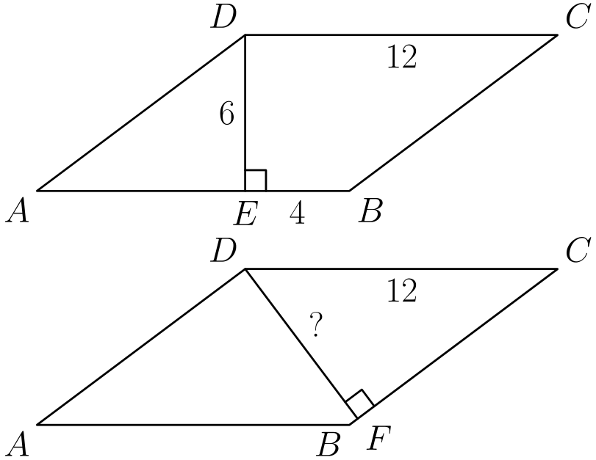
（A）6.4 （B）7 （C）7.2 （D）8 （E）10
English
In parallelogram ABCD, DE is the altitude to the base AB and DF is the altitude to the base BC. (Both pictures represent the same parallelogram.) If DC = 12, EB = 4, and DE = 6, then DF =
(A) 6.4 (B) 7 (C) 7.2 (D) 8 (E) 10
第 25 题
从达拉斯到休斯敦的巴士每小时整点发车。从休斯敦到达拉斯的巴士每小时半点发车。两城之间的行程需要 5 小时。假设巴士都在同一条公路上行驶，一辆开往休斯敦的巴士会在公路上（不在车站内）遇到多少辆开往达拉斯的巴士？
（A）5 （B）6 （C）9 （D）10 （E）11
English
Buses from Dallas to Houston leave every hour on the hour. Buses from Houston to Dallas leave every hour on the half hour. The trip from one city to the other takes 5 hours. Assuming the buses travel on the same highway, how many Dallas-bound buses does a Houston-bound bus pass on the highway (not in the station)?
(A) 5 (B) 6 (C) 9 (D) 10 (E) 11

第二部分 解答
答案速查：
题号 1 2 3 4 5 6 7 8 9
答案 D C E C C C B D C
题号 10 11 12 13 14 15 16 17 18
答案 A D E E B B C D C
题号 19 20 21 22 23 24 25
答案 D B B A B C D
答案串：DCECCCBDCADEEBBCDCDBBABCD
第 1 题 答案 D
这些硬币总共值 1 + 5 + 10 + 25 = 41 美分。
因为一美元是 100 美分，所以这相当于一美元的 41%。
所以正确答案是 <b>D</b>。
English
The coins total 1 + 5 + 10 + 25 = 41 cents.
Since one dollar is 100 cents, this is 41% of a dollar.
Thus, the correct answer is <b>D</b>.
第 2 题 答案 C
扎克是 15 + 3 = 18 岁。
何塞比扎克小 4 岁，所以何塞是 18 - 4 = 14 岁。
所以正确答案是 <b>C</b>。
English
Zack is 15 + 3 = 18 years old.
Jose is 4 years younger, so Jose is 18 - 4 = 14.
Thus, the correct answer is <b>C</b>.
第 3 题 答案 E
除以 3/5 等于乘以 5/3，所以两个运算合起来相当于乘以
3/4 × 5/3 = 5/4。
因此总效果是乘以 5/4。
所以正确答案是 <b>E</b>。
English
Dividing by 3/5 is the same as multiplying by 5/3, so the two operations together multiply by
3/4 × 5/3 = 5/4.
So the combined effect is multiplying by 5/4.
Thus, the correct answer is <b>E</b>.
第 4 题 答案 C
本计算 (6 + 1) × 2 = 14，并把 14 给苏。
苏计算 (14 - 1) × 2 = 26。
所以正确答案是 <b>C</b>。
English
Ben computes (6 + 1) × 2 = 14 and gives 14 to Sue.
Sue computes (14 - 1) × 2 = 26.
Thus, the correct answer is <b>C</b>.
第 5 题 答案 C
整数部分的和为 2 + 3 + 4 + 5 = 14。
分数部分 1/2 + 1/3 + 1/4 + 1/5 约为 1.28，在 1 和 2 之间。因此总和在 15 和 16 之间，大于它的最小整数是 16。
所以正确答案是 <b>C</b>。
English
The whole-number parts sum to 2 + 3 + 4 + 5 = 14.
The fractions 1/2 + 1/3 + 1/4 + 1/5 add to about 1.28, which is between 1 and 2. So the total is between 15 and 16, and the smallest whole number larger than it is 16.
Thus, the correct answer is <b>C</b>.
第 6 题 答案 C
正方形 I 的边长是 12 ÷ 4 = 3，正方形 II 的边长是 24 ÷ 4 = 6。
从图中看，III 的边长是 3 + 6 = 9，所以它的周长是 4 × 9 = 36。
所以正确答案是 <b>C</b>。
English
Square I has side 12 ÷ 4 = 3, and square II has side 24 ÷ 4 = 6.
From the figure, the side of III is 3 + 6 = 9, so its perimeter is 4 × 9 = 36.
Thus, the correct answer is <b>C</b>.
第 7 题 答案 B
乘车或骑车的学生占
1/2 + 1/4 + 1/10 = 10/20 + 5/20 + 2/20 = 17/20。
所以步行的比例是 1 - 17/20 = 3/20。
所以正确答案是 <b>B</b>。
English
The students who ride make up
1/2 + 1/4 + 1/10 = 10/20 + 5/20 + 2/20 = 17/20.
So the fraction who walk is 1 - 17/20 = 3/20.
Thus, the correct answer is <b>B</b>.
第 8 题 答案 D
因为 $1.00 是 $1.60 的 1.00/1.60 = 5/8，所以旅行者会得到 3000 里拉的 5/8。
也就是 5/8 × 3000 = 1875 里拉。
所以正确答案是 <b>D</b>。
English
Since $1.00 is 1.00/1.60 = 5/8 of $1.60, the traveler gets 5/8 of 3000 lire.
That is 5/8 × 3000 = 1875 lire.
Thus, the correct answer is <b>D</b>.
第 9 题 答案 C
每个圆的直径为 4。长方形的短边等于一个直径，所以短边为 4。
因为以 Q 为圆心的圆经过 P 和 R，三个圆半径都是 2，长方形长边跨过两个完整直径：4 + 4 = 8。面积为 8 × 4 = 32。
所以正确答案是 <b>C</b>。
English
Each circle has diameter 4. The short side of the rectangle equals one diameter, so it is 4.
Since the circle at Q passes through P and R, all three circles have radius 2, and the long side spans two full diameters: 4 + 4 = 8. The area is 8 × 4 = 32.
Thus, the correct answer is <b>C</b>.
第 10 题 答案 A
夹克折扣节省 40% 的 $80 = $32，衬衫折扣节省 55% 的 $40 = $22。总共节省 $32 + $22 = $54。
原总价是 $80 + $40 = $120，所以节省比例是 54/120 = 0.45 = 45%。
所以正确答案是 <b>A</b>。
English
The jacket discount saves 40% of $80 = $32, and the shirt discount saves 55% of $40 = $22. The total saved is $32 + $22 = $54.
The original total is $80 + $40 = $120, so the percent saved is 54/120 = 0.45 = 45%.
Thus, the correct answer is <b>A</b>.
第 11 题 答案 D
该区域的周长为 18 个街区，所以简和赫克托相遇时合计走了 18 个街区。因为简的速度是赫克托的两倍，所以简走了 12 个街区，赫克托走了 6 个街区。
从底边中点出发，赫克托走 6 个街区，先到 E，再向上到 D；简走 12 个街区，先到 A，再向上到 B，最后沿上边到 D。所以他们在 D 相遇。
所以正确答案是 <b>D</b>。
English
The perimeter of the region is 18 blocks, so when Jane and Hector meet they have together walked 18 blocks. Since Jane walks twice as fast, she covers 12 blocks and Hector covers 6.
Starting from the middle of the bottom edge, Hector walks 6 blocks (to E, then up to D), and Jane walks 12 blocks (to A, up to B, then across the top to D). They meet at D.
Thus, the correct answer is <b>D</b>.
第 12 题 答案 E
其他年份都可以：90 = 9 × 10、91 = 7 × 13、92 = 4 × 23 和 93 = 3 × 31，都对应合法的月和日。
对 1994，最后两位只能分解为 94 = 2 × 47，而 47 作为日期太大，94 或 47 作为月份也太大。因此 1994 没有幸运日期。
所以正确答案是 <b>E</b>。
English
Each of the other years works: 90 = 9 × 10, 91 = 7 × 13, 92 = 4 × 23, and 93 = 3 × 31, each a valid month/day.
For 1994, the last two digits factor only as 94 = 2 × 47, and 47 is too large for a day (and 94 or 47 is too large for a month). So 1994 has no lucky date.
Thus, the correct answer is <b>E</b>.
第 13 题 答案 E
在三角形 BDE 中，E 和 D 处的角相等，且 ∠ B = 90°，所以 ∠ BED = ∠ BDE = 45°。
因此 ∠ AED = ∠ AEB + ∠ BED = 40° + 45° = 85°。在四边形 AEDC 中，A 和 C 处的角都是 90°，所以
∠ CDE = 360° - 90° - 90° - 85° = 95°。
所以正确答案是 <b>E</b>。
English
In triangle BDE, the angles at E and D are equal and ∠ B = 90°, so ∠ BED = ∠ BDE = 45°.
Then ∠ AED = ∠ AEB + ∠ BED = 40° + 45° = 85°. In quadrilateral AEDC, the angles at A and C are 90°, so
∠ CDE = 360° - 90° - 90° - 85° = 95°.
Thus, the correct answer is <b>E</b>.
第 14 题 答案 B
整个赛季共有 50 + 40 = 90 场比赛，90 的 70% 是 63 场胜利。
球队已经赢了 40 场，所以还需要赢 63 - 40 = 23 场。
所以正确答案是 <b>B</b>。
English
The season has 50 + 40 = 90 games, and 70% of 90 is 63 wins.
The team already has 40 wins, so it needs 63 - 40 = 23 more.
Thus, the correct answer is <b>B</b>.
第 15 题 答案 B
4/37 = 0.108，循环节长度为 3。第 3、6、9、… 位，也就是位置为 3 的倍数时，数字是 8。
因为 99 是 3 的倍数，所以第 99 位是 8，第 100 位开始下一个循环节，是 1。
所以正确答案是 <b>B</b>。
English
4/37 = 0.108, repeating with block length 3. The digits in positions 3, 6, 9, … (multiples of 3) are 8.
Since 99 is a multiple of 3, the 99th digit is 8, so the 100th digit starts the next block: it is 1.
Thus, the correct answer is <b>B</b>.
第 16 题 答案 C
总工作量为 7 × 3 + 4 × 5 + 5 × 9 = 21 + 20 + 45 = 86 人天。
所以每人每天的报酬为 $774 ÷ 86 = $9。巴尔博亚学生的总工作量为 20 人天，共赚得 20 × $9 = $180。
所以正确答案是 <b>C</b>。
English
The total student-days are 7 × 3 + 4 × 5 + 5 × 9 = 21 + 20 + 45 = 86.
So each student-day pays $774 ÷ 86 = $9. Balboa worked 20 student-days, earning 20 × $9 = $180.
Thus, the correct answer is <b>C</b>.
第 17 题 答案 D
安维尔的六年级人数为 11% 乘以 100 = 11 人；克利奥纳的六年级人数为 17% 乘以 200 = 34 人。
合计为 11 + 34 = 45 人，占总人数 300 的 45/300 = 15%。
所以正确答案是 <b>D</b>。
English
Annville has 11% of 100 = 11 sixth graders, and Cleona has 17% of 200 = 34 sixth graders.
Combined, that is 11 + 34 = 45 out of 300 students, which is 45/300 = 15%.
Thus, the correct answer is <b>D</b>.
第 18 题 答案 C
四个 L 形区域合计占 4 × 3/16 = 3/4 的大正方形，所以中心正方形占剩下的 1/4。
大正方形面积为 100 × 100 = 10000 平方英寸，所以中心正方形面积为 1/4 × 10000 = 2500，边长为 √(2500) = 50 英寸。
所以正确答案是 <b>C</b>。
English
The four L-shaped regions cover 4 × 3/16 = 3/4 of the square, so the center square is the remaining 1/4 of the total area.
The total area is 100 × 100 = 10000 square inches, so the center square has area 1/4 × 10000 = 2500, and its side is √(2500) = 50 inches.
Thus, the correct answer is <b>C</b>.
第 19 题 答案 D
图中有 2 个家庭有 1 个孩子，1 个家庭有 2 个，2 个家庭有 3 个，2 个家庭有 4 个，6 个家庭有 5 个，总共 2 + 1 + 2 + 2 + 6 = 13 个家庭。
中位数是按顺序排列的第 7 个值。列出家庭孩子人数后，第 7 个值是 4。
所以正确答案是 <b>D</b>。
English
The graph gives 2 families with 1 child, 1 with 2, 2 with 3, 2 with 4, and 6 with 5, for 2 + 1 + 2 + 2 + 6 = 13 families.
The median is the 7th value in order. Listing the family sizes, the 7th value is 4.
Thus, the correct answer is <b>D</b>.
第 20 题 答案 B
共有 6 × 6 = 36 个等可能结果，其中 6 个是平局，剩下 30 个结果两数不同。
由对称性，戴安娜的数较大的情况正好是其中一半，即 15 个。所以概率为 15/36 = 5/12。
所以正确答案是 <b>B</b>。
English
There are 6 × 6 = 36 equally likely outcomes, of which 6 are ties, leaving 30 outcomes with different numbers.
By symmetry, Diana is larger in exactly half of those, or 15, so the probability is 15/36 = 5/12.
Thus, the correct answer is <b>B</b>.
第 21 题 答案 B
每个立方体唯一的凸扣都必须插入另一个立方体的孔中才能被隐藏。两个立方体只能共用一个面，因此无法同时隐藏两个凸扣。若用三个立方体隐藏所有凸扣，就需要形成一个三立方体闭环，使每一对立方体都共用一个面；但三个单位立方体不可能两两以面相邻。因此，一个、两个或三个立方体都不行。
四个立方体可以排成一个方形环，每个凸扣插入相邻立方体的孔中，从而外面只露出孔。因此最少需要 4 个。
所以正确答案是 <b>B</b>。
English
Every cube’s single snap must be plugged into another cube’s hole to be hidden. Two cubes can share only one face, so two cubes cannot hide both snaps. With three cubes, hiding all three snaps would require a three-cube loop in which every pair shares a face, but three unit cubes cannot be pairwise face-adjacent. Thus one, two, or three cubes cannot work.
Four cubes can be arranged in a square ring, each snap fitting into the neighbor’s hole, so only receptacle holes show. The smallest number is 4.
Thus, the correct answer is <b>B</b>.
第 22 题 答案 A
质因数分解为 6545 = 5 × 7 × 11 × 17。要分成两个两位因数，可以配为 5 × 17 = 85 和 7 × 11 = 77。
这是唯一的两位数配对，它们的和是 85 + 77 = 162。
所以正确答案是 <b>A</b>。
English
The prime factorization is 6545 = 5 × 7 × 11 × 17. To split into two two-digit factors, pair the primes: 5 × 17 = 85 and 7 × 11 = 77.
These are the only two-digit pair, and their sum is 85 + 77 = 162.
Thus, the correct answer is <b>A</b>.
第 23 题 答案 B
第一位是奇数，有 5 个选择。第二位是偶数，有 5 个选择，而且不会与第一位的奇数重复。
第三位可以是剩下 8 个未用数字中的任意一个，第四位有 7 个选择。总数为 5 × 5 × 8 × 7 = 1400。
所以正确答案是 <b>B</b>。
English
The first digit is odd: 5 choices. The second is even: 5 choices (none of which repeats the odd first digit).
The third digit is any of the 8 unused digits, and the fourth is any of the 7 remaining. In total, 5 × 5 × 8 × 7 = 1400.
Thus, the correct answer is <b>B</b>.
第 24 题 答案 C
因为 AB = DC = 12，所以 AE = 12 - 4 = 8。在直角三角形 ADE 中，AD = √(8² + 6²) = 10，因此 BC = AD = 10。
面积为 AB · DE = 12 · 6 = 72，同时也等于 BC · DF = 10 · DF。所以 DF = 72/10 = 7.2。
所以正确答案是 <b>C</b>。
English
Since AB = DC = 12, we get AE = 12 - 4 = 8. In right triangle ADE, AD = √(8² + 6²) = 10, so BC = AD = 10.
The area is AB · DE = 12 · 6 = 72, and also BC · DF = 10 · DF. So DF = 72/10 = 7.2.
Thus, the correct answer is <b>C</b>.
第 25 题 答案 D
考虑一辆 6:00 从达拉斯出发、11:00 到休斯敦的巴士。它会遇到所有在这段时间内与它同在公路上的开往达拉斯的巴士。
开往达拉斯的巴士每半点从休斯敦出发，行程 5 小时。与这辆车在路上相遇且不在车站相遇的，是 1:30、2:30、…、10:30 从休斯敦出发的巴士，共 10 辆。
所以正确答案是 <b>D</b>。
English
Consider a bus leaving Dallas at 6:00, arriving in Houston at 11:00. It meets every Dallas-bound bus that is on the highway during that window.
Dallas-bound buses leave Houston on the half hour and take 5 hours. The ones sharing the road (meeting away from a station) are those that left Houston at 1:30, 2:30, …, 10:30, which is 10 buses.
Thus, the correct answer is <b>D</b>.

